Pre-Calculus 2015 – 2016 Name________________________

Ticket to Retake Rational Functions Quest Block__________ Date_________

**NO CALCULATOR**

1) For the following function, find the asymptotes and explain their meaning.



2) Solve:  3) Solve: 

4) Graph the following function, showing asymptotes, intercepts and discontinuities in the graph.



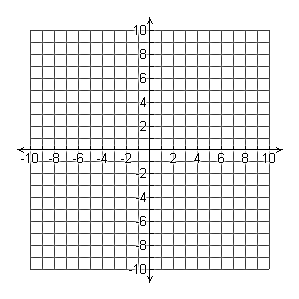

5) Graph the following function, showing asymptotes, intercepts and discontinuities in the graph.





6) Graph the following function, showing asymptotes, intercepts and discontinuities in the graph.





7) Graph the following function, showing asymptotes, intercepts and discontinuities in the graph.





8) Write the equation of the following graph.

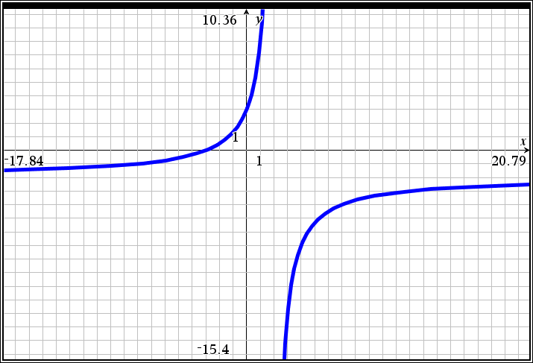

9) Describe, in complete sentences, how to find the vertical asymptotes for a rational function. Explain whether or not all rational functions have vertical asymptotes.